Chapter 10, Solution 33.
5 A
2 I
4 
2 
+
−
-j20 V
-j2 
I₂
I₁
I₄
I₃
j 
I

Consider the circuit shown below.

For mesh 1,
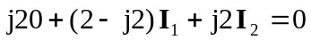
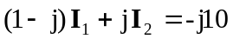 (1)

For the supermesh,
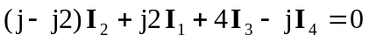 (2)

Also,
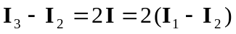
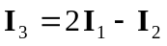 (3)

For mesh 4,
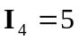 (4)

Substituting (3) and (4) into (2),
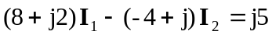 (5)

Putting (1) and (5) in matrix form,
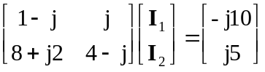

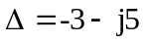, 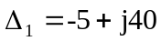, 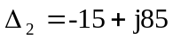

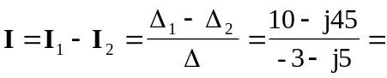

7.90643.49 A

